Modernization of Central Workshop at CUET

Introduction: The vision of the Central workshop project is to provide the facilities for advanced research with advanced tools and machineries. The project implementation mainly includes small refurbishing works, procurements of equipment following PPA rules, installation of the equipment, safety training, seminar on machine tools for the users, preparation of manual, organizing training on CNC machining, etc.
Sometime it is happened that some of the students who enrolled for Post graduate/Graduate program are not highly motivated to pursue their thesis/Project work in their respective departments due to lack of a common workshop based facilities where they could prepare the necessary items for their research project. This central workshop will cope with all the research activities of different entities.

Implement period:
Duration: 2 Years.
Extended Period: 7 (6+1) Months.
Commencement: 01 Jul, 2014 .
Completion : 31 January, 2017.
Total Budget:
In Taka : 19700000,
In US$ : 246250,
Place of Implementation: Central Workshop, Chittagong University of Engineering & Technology.

Basic Activities List: For making the project success, there are some missions set up to attain the goal:
- Manpower Development.
- Maintenance and scheduling activities of workshop lab.
- Helping the students during working in the lab
- Increment of reading facilities in workshop.
- Organizing training, workshop and seminar.
- Creating links with industries to solve practical problem.

Members of SPMT: Success of any project mainly depends upon the leadership. For controlling and monitoring the project work SPM select some proactive members for his sub-project. They are:
SPM: Prof. Dr. Sajal Chandra Banik, Dept. of ME, CUET.
DSPM: Prof. Dr. Sheikh Muhammad Humayun Kabir, Dept. of ME, CUET.
SPMT Member1: Prof. Dr. Kazi Afzalur Rahman, Dept. of ME, CUET.
SPMT Member 2: Muhammed Kamrul Islam, Asst. Professor, Dept. of ME, CUET.

List of Machineires, equipments and others:

Serial No. | Description
1 | CNC Toolroom lathe & accessories.
2 | CNC Minimill with accessories.
3 | Basic Pneumatic training/Equipment set
4 | CNC Drilling Milling Machine & accessories.
5. | 2 3D printer for job practice
6 | One Photocopier.
7 | Four Desktop, 3 Laptop, 2 Printer, 2 scanner, 1 mulitmedia projector
8 | Furniture & Fixtures for class in the lab
9 | Air conditioning system
10 | Books related to CNC machines and programimg

Some Photos of the Lab

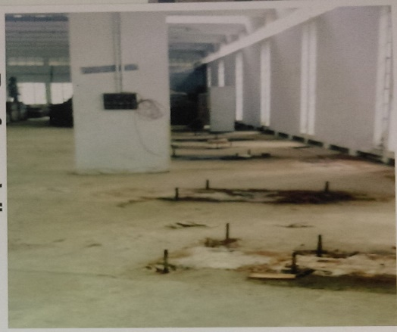 | 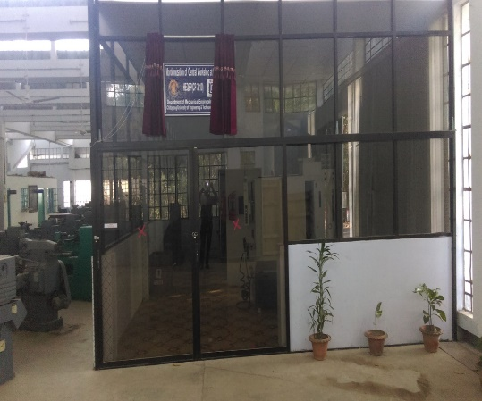
Before | After

- Machineries:

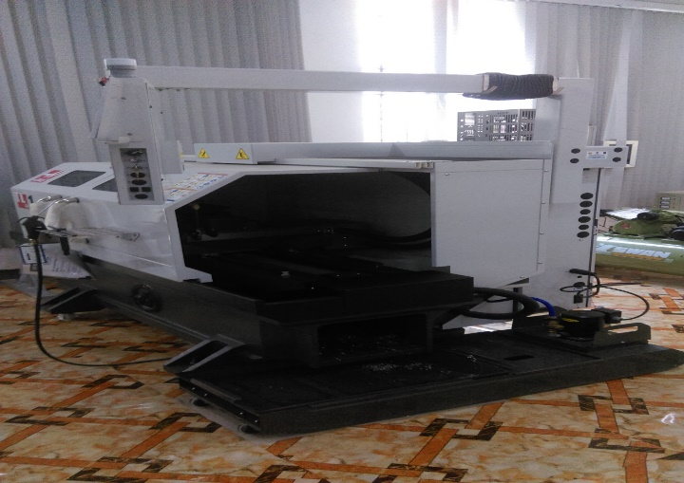 | 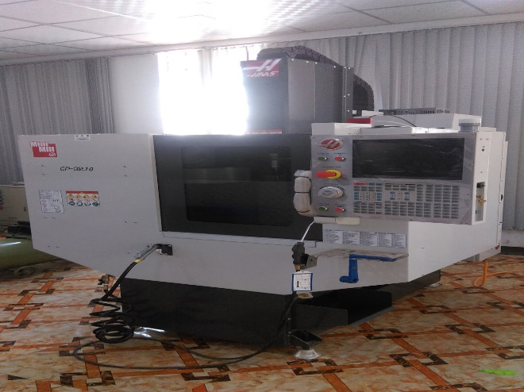
CNC Toolroom lathe | CNC Minimill
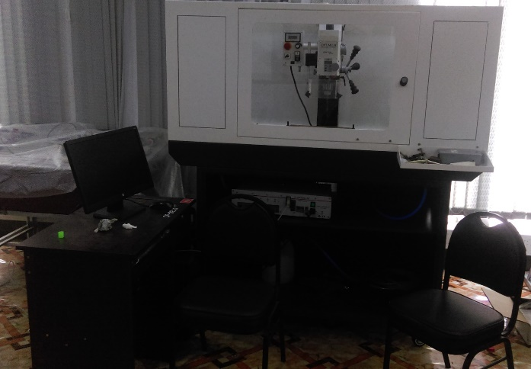 | 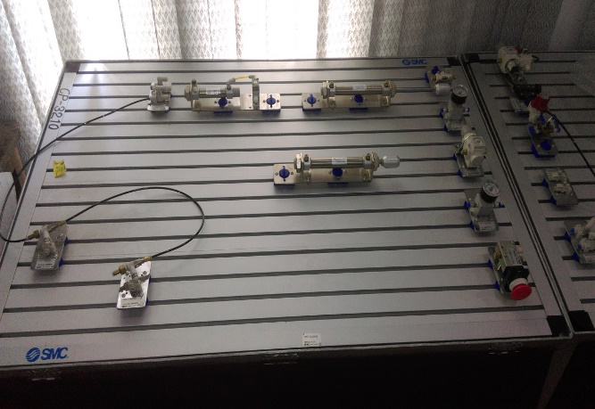
CNC Drilling Milling Machine with accessories | Basic Pneumatic Equipment set

- Inauguration Event:

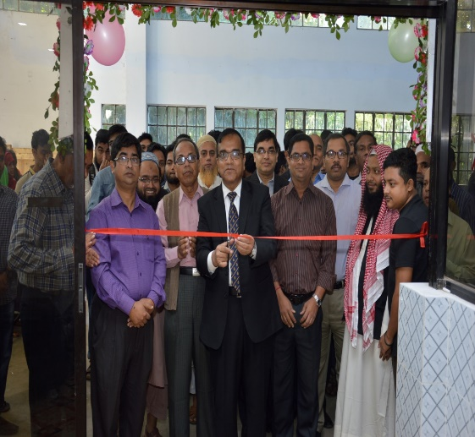 | 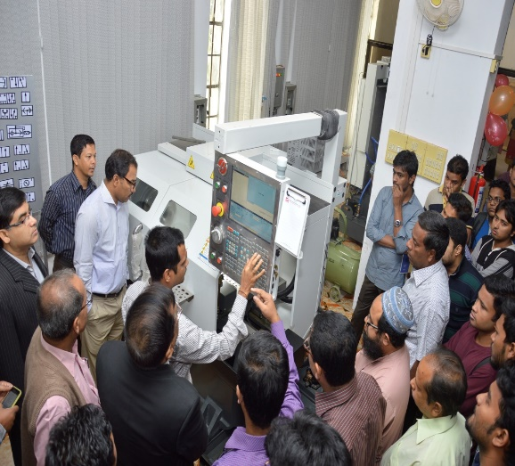
8th December, 2016

- Training

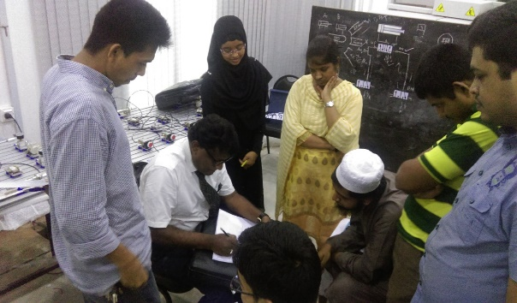 | 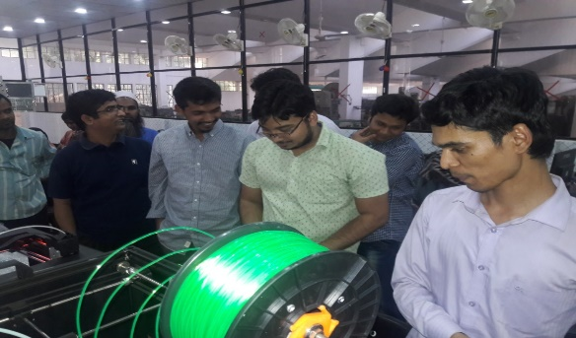
Training on Pneumatic System | Training on 3D Printing
Orgnized Seminar/Workshop
- Workshop on Modern Machining and Car Manufacturing Technology:
  - Date: 08-11 Dec, 2016
  - Number of Participants: 130
  - 3 Keynote Speakers:
i. Engr. Ashish Singh, CEO, Ashman Motors & Technology, India.
ii. Engr. Puspeswar Singha Roy, Mechanical Division, Progoti Industries Ltd.
iii. Engr. Nahin Bahar Chowdhury, KSRM Ltd.

Some Pictures on Workshop

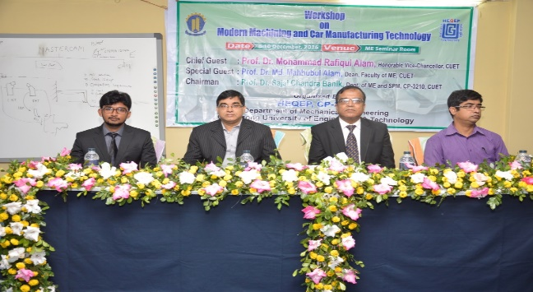 | 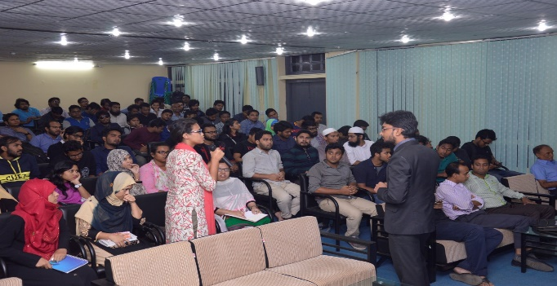

ii) Seminar on CNC Machining:
- Date: 26th January, 2017
- Number of Participants: 75
- 3 Keynote Speakers: Prof. Dr. Abdullahil Azeem, Dept. of IPE, BUET.
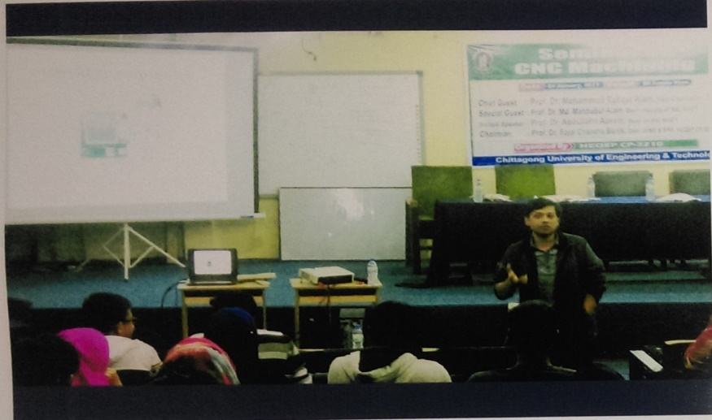

Current Activities:
The following sessional courses are being conducted in the lab using the CNC machines, Pneumatic control Kits and 3D printer.
Department/Level | Course Description
ME: Level 2, Term I | ME 252: Production Process Sessional
ME: Level 4, Term II | ME452: Machine Tools and Tool Engineering
ME: Level 4, Term II | ME456: Mechatronics
MIE: Level 2 Term I | MIE 214: Mechatronics Workshop
MIE: Level 3 Term II (will be started) | MIE 314: Industrial Automation Sessional
MIE Level 1 Term II | MIE122: Fabrication Laboratory
Postgraduate students | Students performed their project related works

Other than these, some professional courses are being conducted like for Officers of Naval Academy.
Also various workshops/training/seminar are organized in the lab.

Contact Person:
- Prof. Dr. Sajal Chandra Banik, Dept. of ME, CUET.
- Prof. Dr. Sheikh Muhammad Humayun Kabir, Dept. of ME, CUET.
- Prof. Dr. Kazi Afzalur Rahman, Dept. of ME, CUET.
- Muhammed Kamrul Islam, Asst. Professor, Dept. of ME, CUET.
- Nurun Nahar Begum, Lecturer, Department of MIE, CUET

