SOFTWARE DONATION BY PETEX
DATE: NOVEMBER, 18, 2022
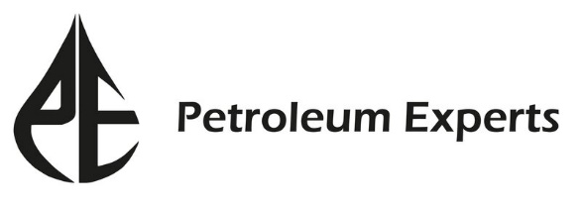
We are delighted to announce that Petroleum Experts has kindly renewed the license (Educational License) for IPM suite software at the Department of Petroleum and Mining Engineering. It is our privilege to announce that Petroleum Experts has provided us with 10 licenses for using their IPM suite which includes PROSPER, GAP, PVTP, MBAL, REVEAL, and RESOLVE along with a Hardlock. The approximate market value of this suite is £2,584,803.70 and the license will be effective for 1 year (till 13 December 2023). We believe that this software will be highly beneficial for teaching, tutorials, non-commercial research, and for relevant undergraduate courses.

